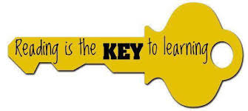
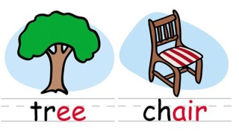
Free Phonics Workshop!
For parents with children in Reception and Year 1
Wednesday 18th September 3.30pm
Don’t know your phonemes from your digraphs? We can help!
Phonics is the basis of how we teach children to read and in Reception and Year 1 is where the building blocks are really put into place. The jargon surrounding phonics can all seem a little alien to those new to using it, so we invite you to come along to our workshop, let us explain the basics, have a go yourselves and hopefully help you to better understand the phonics learning that goes on at St Paul’s.
Children in Year 1 will take part in a National Phonics Screening Check in June 2020, and we would like to explain a bit more about this check and why children are required to take it.
If you would like to come to the workshop, and those who have come before you are most welcome to come again, please complete the form below and return it to your child’s class teacher. We had brilliant feedback from our previous workshops, parents found them very useful, especially for helping with reading books at home.
School children are not invited to attend the workshop. Therefore, we will be providing afterschool care for the duration of the meeting. If this is something you require please indicate on the slip below. (Please note that we can only offer afterschool care to current pupils of St Paul’s)
Please collect your children as normal at 3.15pm, and then come around to the front of school, the workshop will be in the hall and after school care in a nearby classroom.
We really hope to see you there! (there might even be tea and biscuits!)
Kindest regards,
Mrs Owen
I/We___________________________________ will be attending the parents phonics workshop on Weds 18th Sept.
Afterschool Care required? Y / N (please circle) Number of Children ___
Signed: ___________________________

